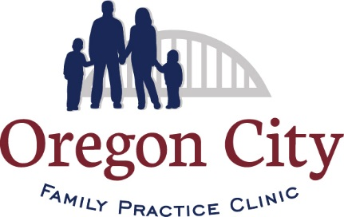 Coronavirus (COVID-19)

This is an evolving situation. The Covid-19 Policy & Procedure will be updated as needed.

As our community moves towards reopening and resuming many of our normal daily activities, it’s vital that you do not delay any needed care. Now’s the time to focus on health!

Appointments & Care

We are open for in-office care, however, we are seeing patients in the clinic on a limited basis. We’re committed to providing the care you need in the safest way possible. To request an appointment, please call our office.

We’re committed to your safety.

Our goal is to make our Clinic spaces the safest place you can receive care.
- Masking all teammates and patients.
- Laboratory appointments by appointment only.
- Reducing the number of people on-site by staggering appointments.
- Enhancing social distancing cues in our waiting areas, so that there is only one patient at a time in our lobby.
- Keeping COVID-19 care and other in-person care separate.
- Thorough sanitation of each exam room after a patient has left.
- Phone protocol screening of each patient before an in-office visit.
- Evaluation of the necessity of face-to-face care based on the clinical needs of the patient.

Virtual Care

Virtual care is a simple, safe, and secure way for you to talk with your provider and care team without having to come into the Clinic. Virtual care will continue to be a convenient option for many patients, including those at higher risk.
We are carefully monitoring the CDC and State guidance.

