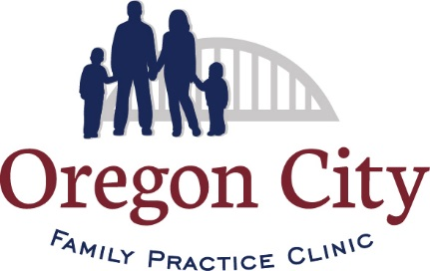 Coronavirus (COVID-19) Company Policy & Procedures Regarding Patients & Staff

This Coronavirus (COVID-19) company policy regarding patients is susceptible to changes with the introduction of additional governmental guidelines. If so, we will update you as soon as possible.

This policy includes the measures we are actively taking to mitigate the spread of Coronavirus but allowing staff to take care of our patients. You are required to follow all these rules diligently, to sustain a health and safe workplace in this unique environment. It’s important that we all respond responsibly and transparently to these health precautions.

Scope

This Coronavirus policy & procedures applies to all patient flow, triage, treatment, appointments and patient contact, as well as staff protocol until further notice.

Policy Elements

Office Preparation:
- Hand sanitizer, face shields/goggles, surgical masks, gloves and gowns will be provided for staff. If a shortage occurs, we will notify staff.

Patient Appointment with no COVID-19 Symptoms:
- Evaluate patients on a case-by-case basis. Determine if the patient needs to be seen in the office or if Tele-health is appropriate.
- If the patient is being seen in the office, they will need to wear a face mask.
- No more than one patient is to be in the waiting area at a time.
- Staff must wear a face mask.

Patient Appointment with a fever or other respiratory symptoms:
- If patient needs to be seen in the office and Tele-health is not an option, the provider and MA will go to the patient’s car. This will be determined by the provider.
- Full PPE must be worn.

Patient Appointment with Suspected COVID-19:
- Evaluate patients on a case-by-case basis. If presenting symptoms, travel history, and/or contacts are suspicious, and it is determined that the patient must be seen, have the patient call prior to their arrival to make preparation for accommodation.
- Full PPE must be worn.
- Conduct the patient evaluation outside at the patient’s car. If that is not possible, immediately isolate the patient to a designated exam room near one of the side doors and make sure they are wearing a face mask.
- Follow standard precautions and transmission-based precautions, using gloves, gowns, protective eyewear and an N95 mask
- Limit staff exposure to suspected patients, with exam room door kept closed.
- Through our EMR, it is tracked on who has had contact with the patient (Lab, Physician, MA).
- Once the patient exits the exam room, conduct surface disinfection while staff continues to wear PPE.
- Provide up-to-date, information on the virus to the patient, including how to follow infection-control practices at home, such as in-home isolation, hand hygiene, cough etiquette, waste disposal, and the use of face masks.
- Remind the patients and their families to access information about the virus through reputable sources, such as the CDC, not social media.

General Hygiene Rules:
- Follow the 20-second hand-washing rule. Hand sanitizer is place around the office as well.
- Cough/sneeze into your elbow. If you use a tissue, discard it properly and clean/sanitize your hands immediately.
- Avoid touching your face, particularly eyes, nose, and mouth with your hands to prevent from getting infected.
- Wear your mask.
- At the end of your day, place your mask in a brown bag for 72 hours. Rotate your masks.

Sick Leave Arrangements:
- If you have cold symptoms, such as cough, sneezing, fever, or feel poorly, request sick leave.
- If you have a positive COVID-19 diagnosis, you can return to work, only after you have fully recovered, possibly 14 days or more.
- If you need to provide care to a family member infected by COVID-19, you will only be permitted to return to work 14 calendar days after your family member has full recovered, if you’re asymptomatic.

We are carefully monitoring the CDC and State guidance

Updated: 05/08/2020

